28. Process Builder - 01 April 2022

Process Builder: It is an Automation Tool and the advanced version of the workflow rules with graphical representation. It has more functionality than workflow rules.

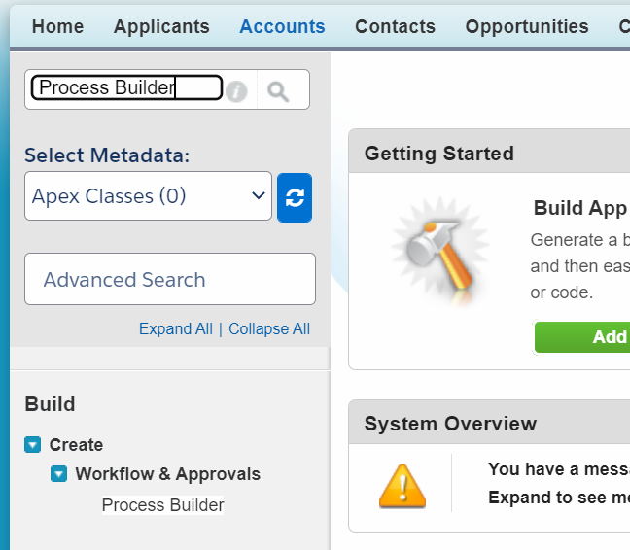

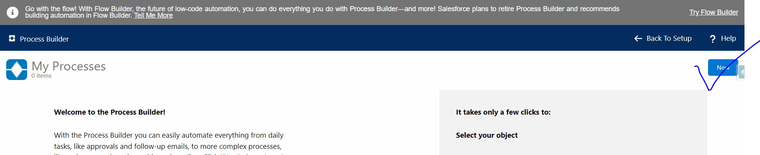

User Story 1: When Account Rating is “Hot” and Type is “Prospect”, then SLA should be Gold. Else, SLA will be Blank.

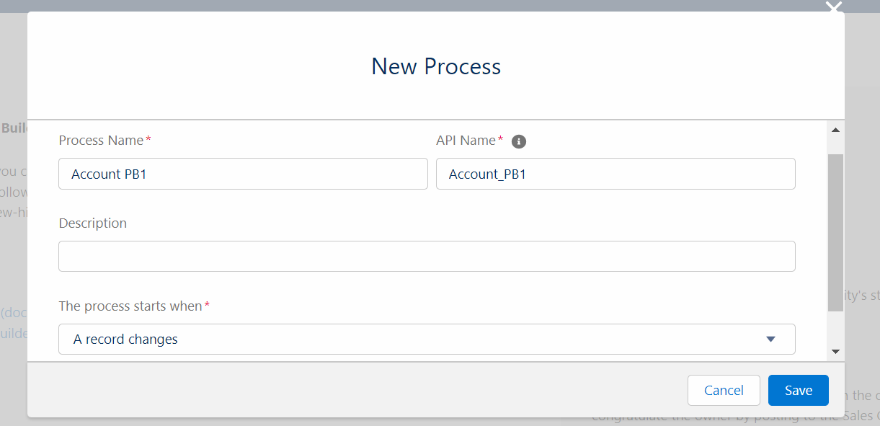

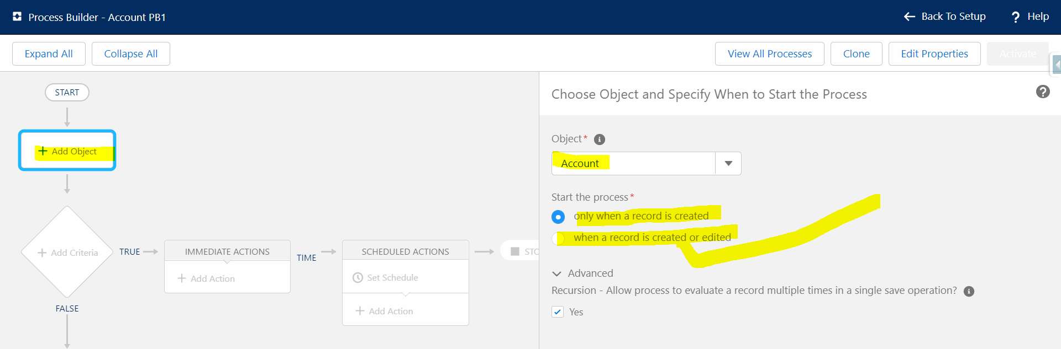

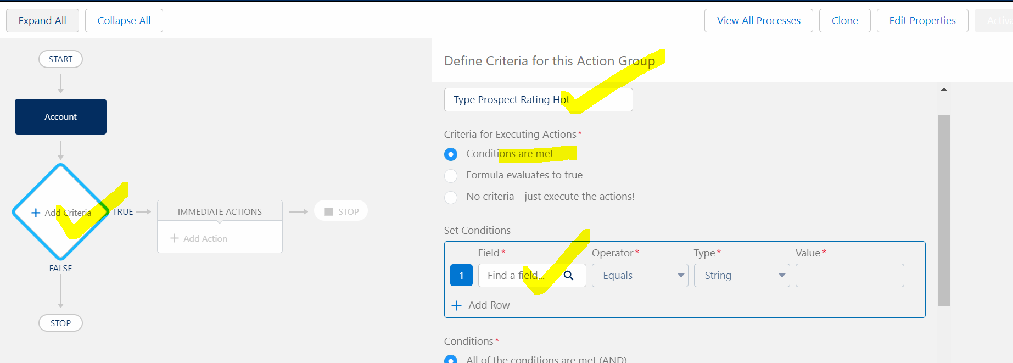

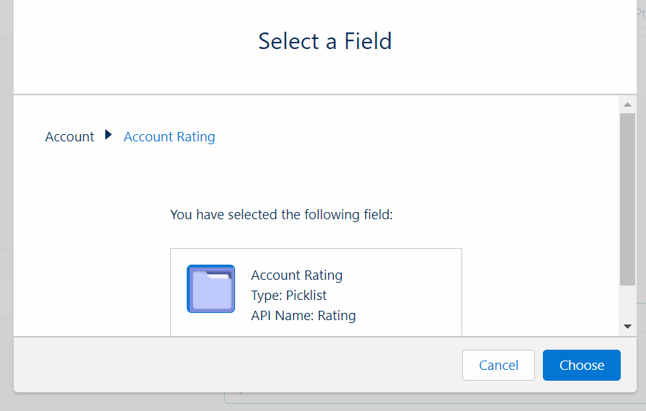

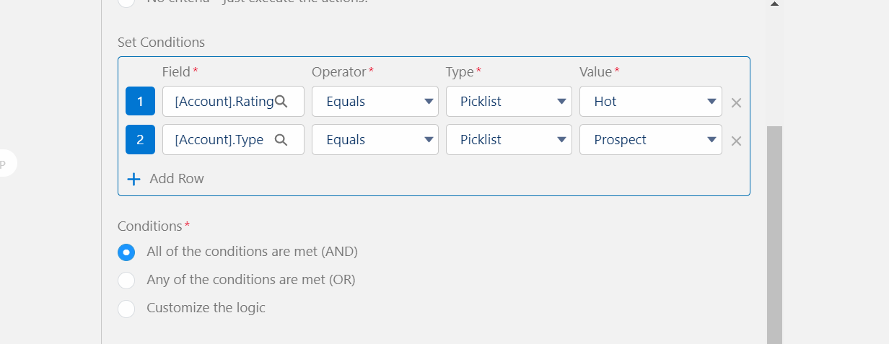

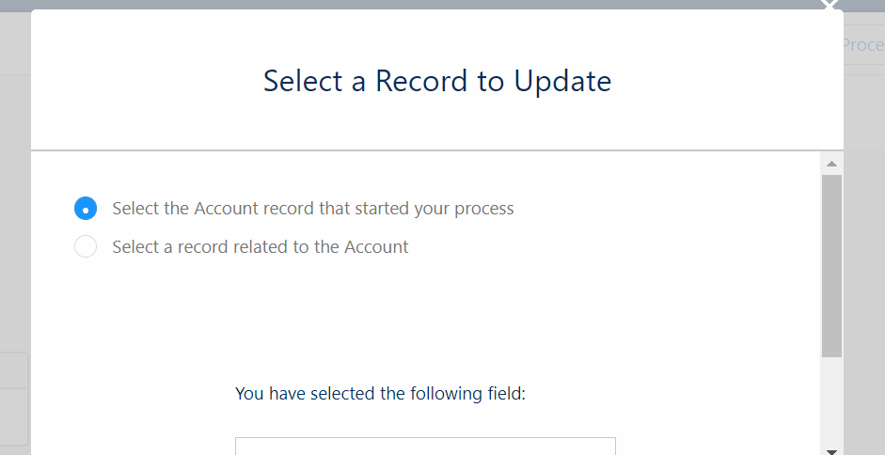

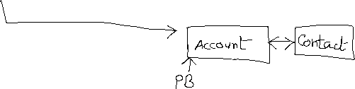

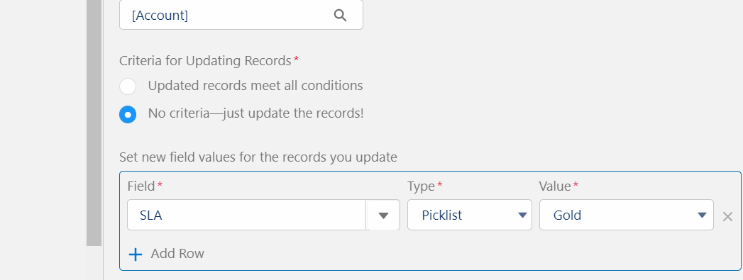

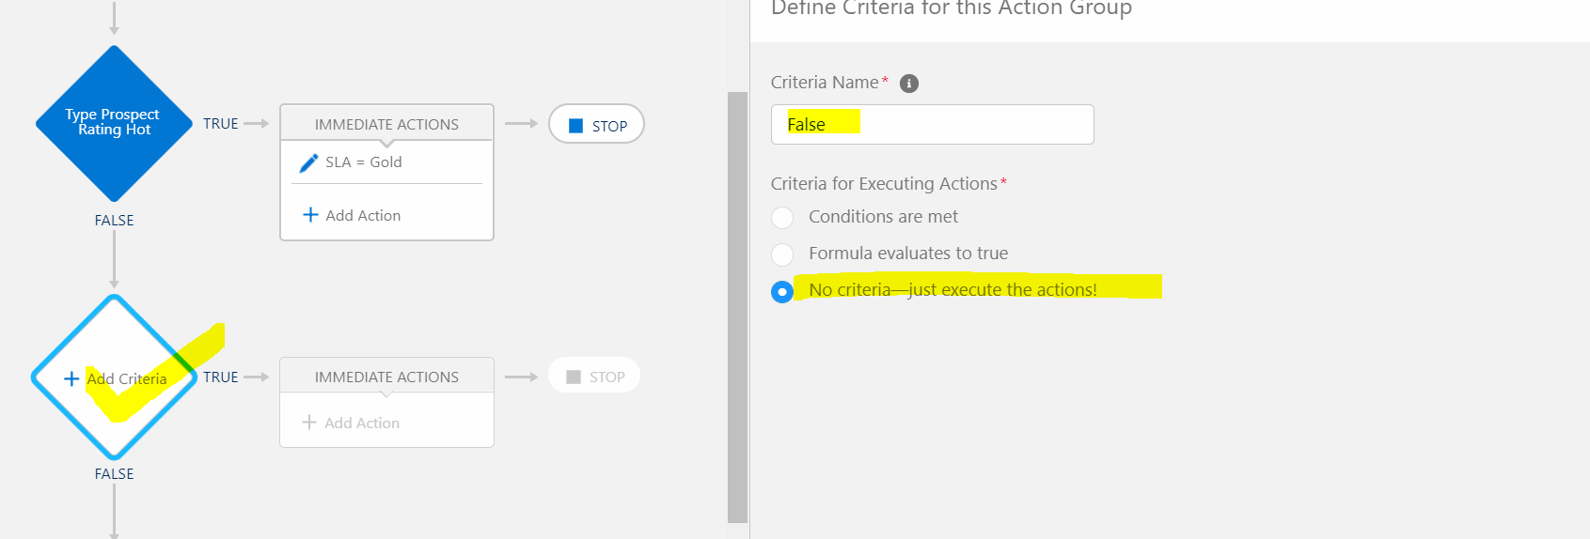

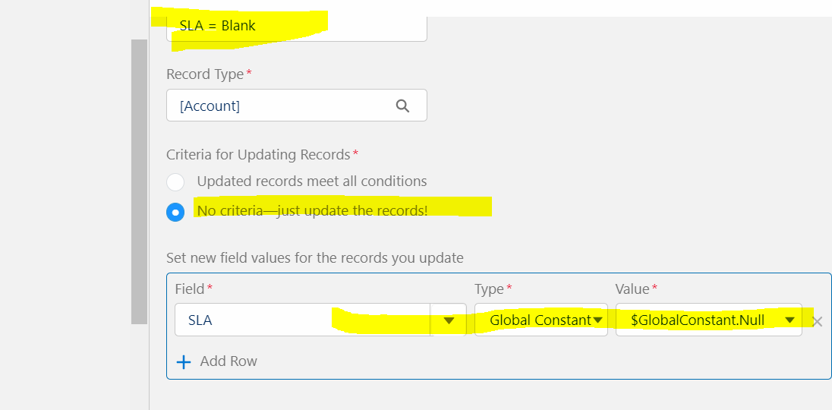

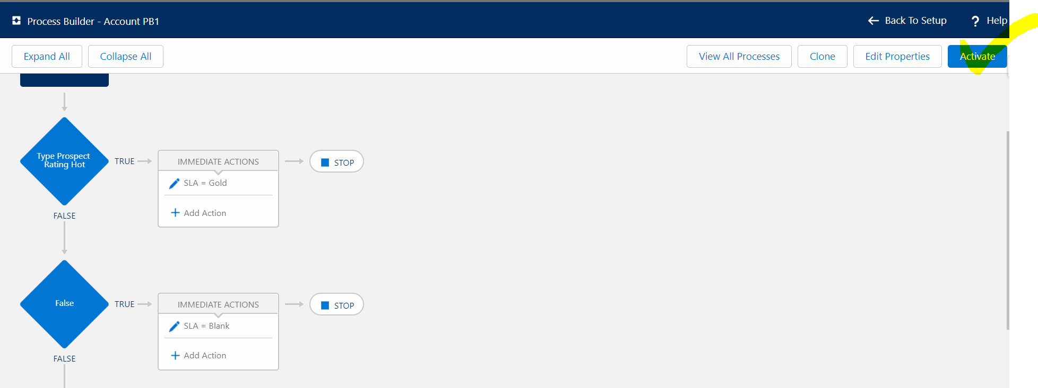

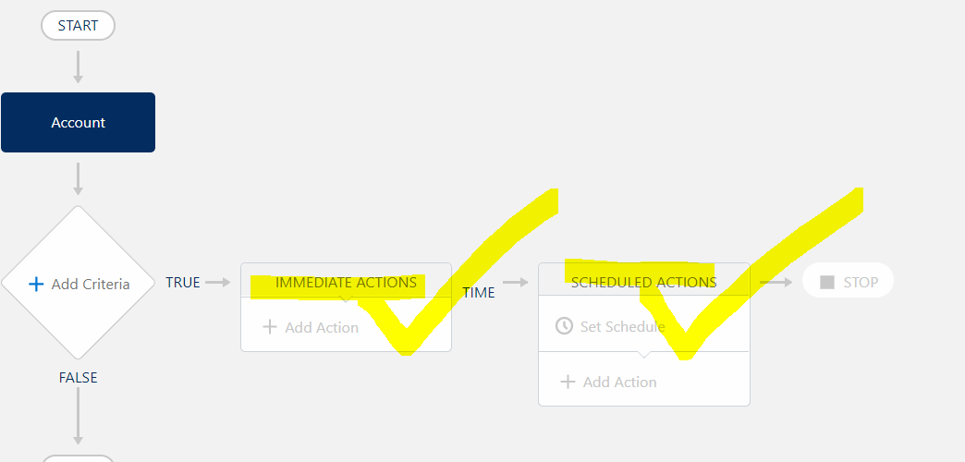

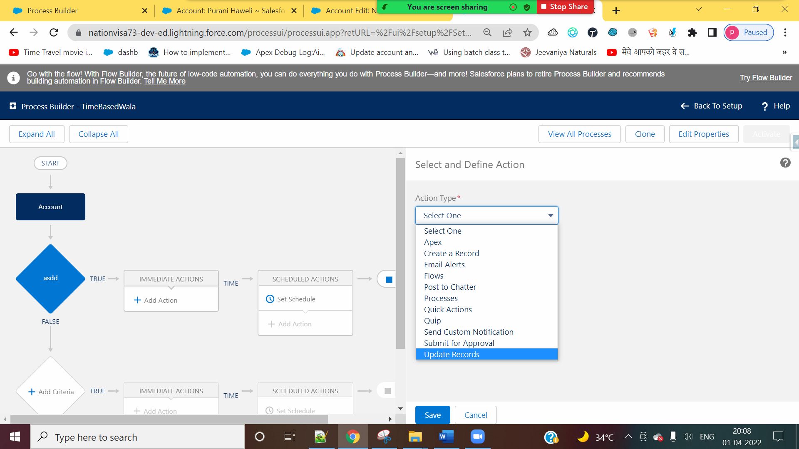



Relationship:

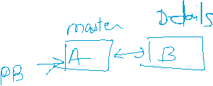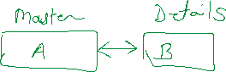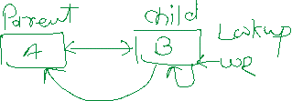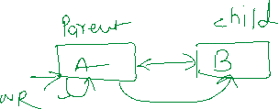

User Story 2 : If a new Address is created / Edited, and If City is “Pune”, then Applicant must be eligible for Police Verification, Else Not.

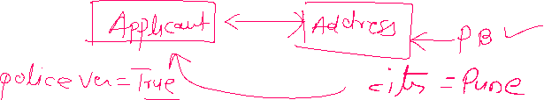

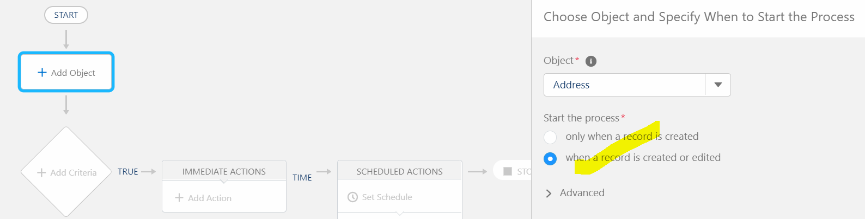

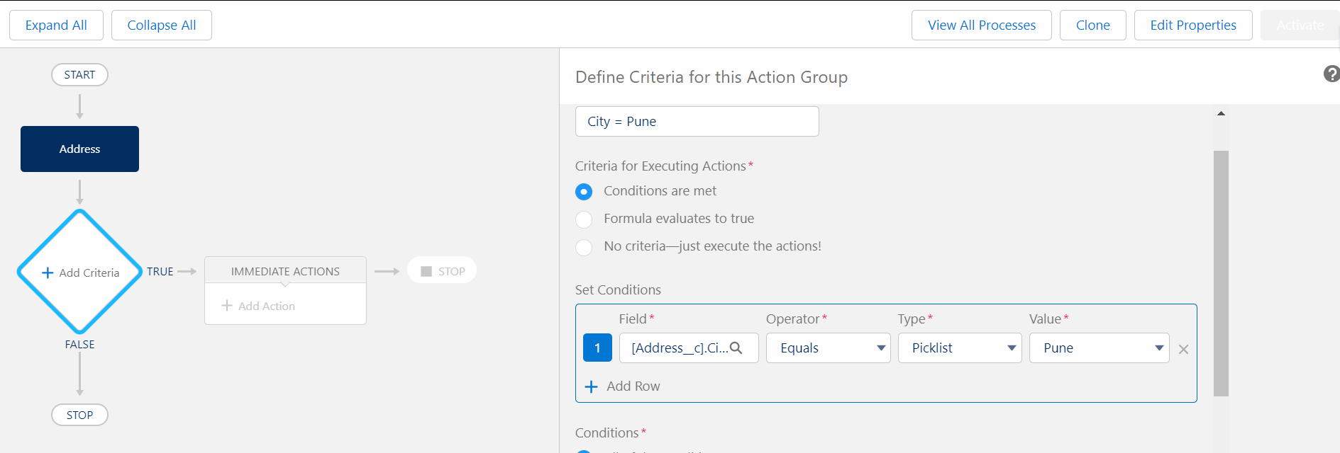

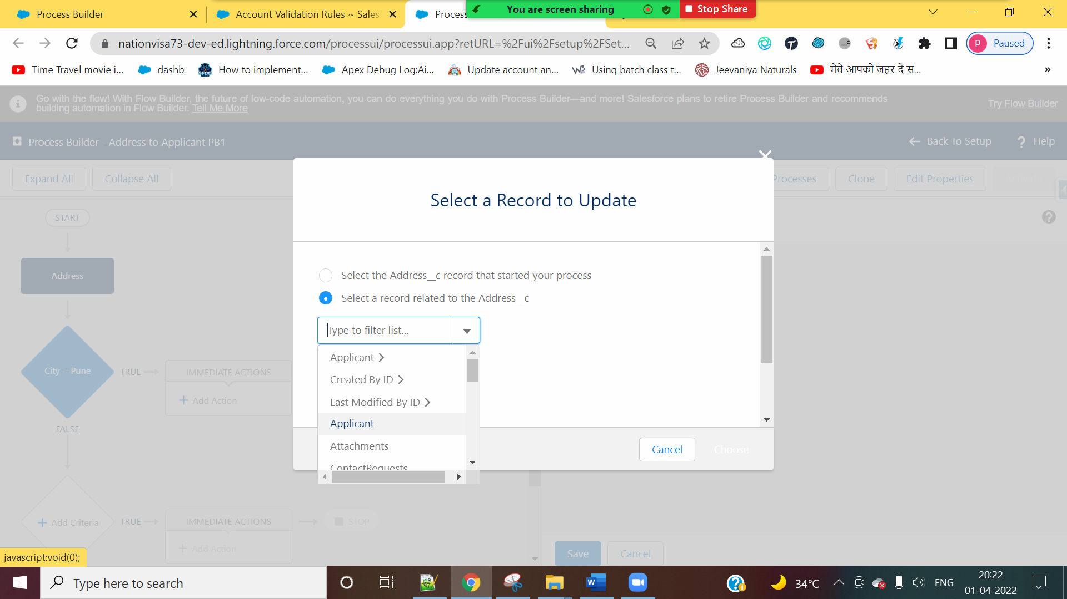



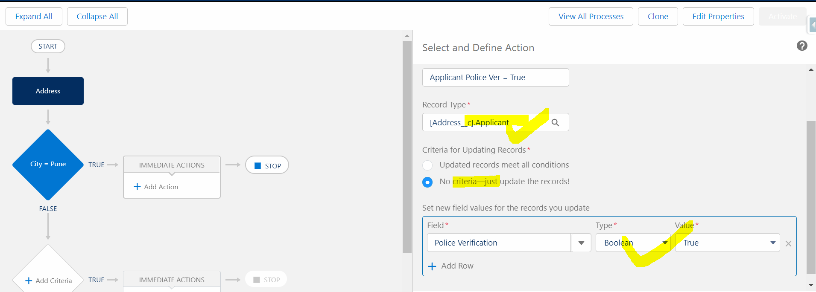

User Story 3] Applicant 🡨 🡪 Address

Whenever Applicant Gender is Transgender, then All the Address Pin Code must be 440018. Else 440020.



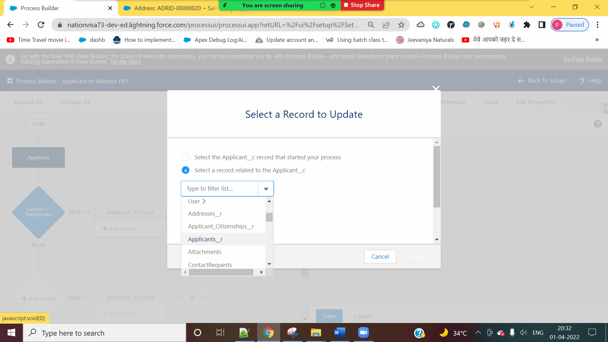

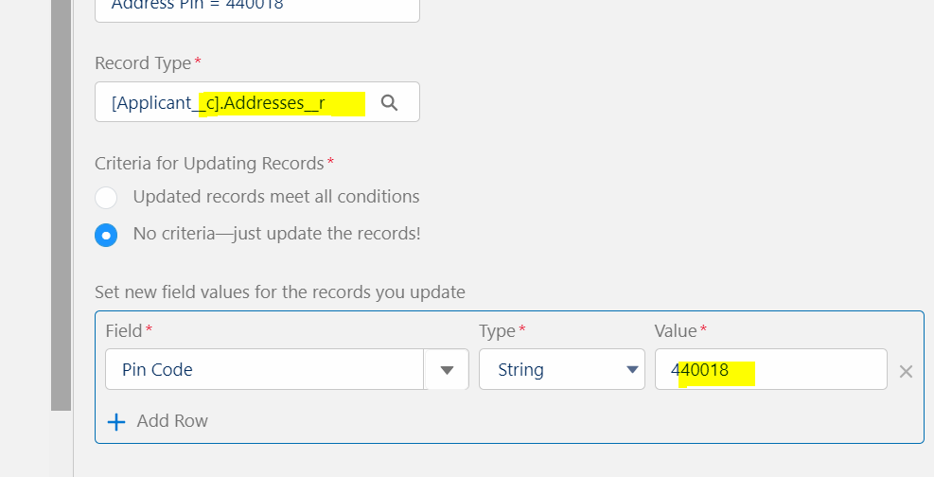



Assignment:

0] : If Passport Status = “Dispatched”, then Applicant Passport Messages = “Your Passport has been Dispatched”. Else None.

1] If we update Applicant record, and if we select Police Verification as TRUE, then show a message “This Applicant is now eligible for Police Verification” on Address field “Applicant Message”. Else , keep it blank.

NOTE – Kindly create a field Applicant Message on Address Object.

2] If we update Applicant record, and if we select Police Verification as TRUE, then Set Passport Status to “Rejected”.

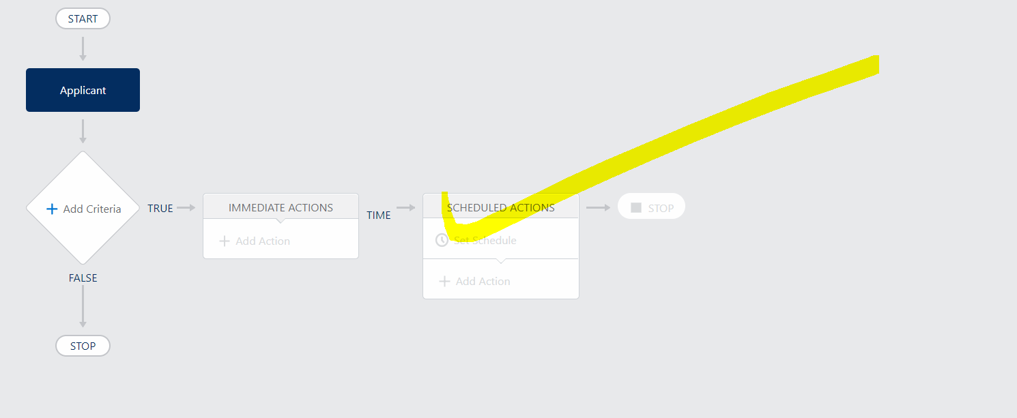

Diff between Workflow Rule and Process Builder (100%)

|  |  |
| --- | --- |
| Workflow Rule | Process Builder |
| 1] Action : Task, Field Update, Email Alert, Outbound Messages | 1] Task, Field Update, Email Alert, Apex Class and much more. |
| 2] We can update Master object Field from Details Object (Workflow) , but not vice-versa | 2] This is possible in PB. (Event in the case of Lookup) |
| 3] We can not use DML Statement (Apex Code). | 3] We can use DML statement (Apex Code) |

Topics:

1] Record Type = 01 (Video)

2] Reports and Dashboards = (03) (Videos)

By 05th April 2022 + Mini Project

====================ADMIN=====================

|

GAP : 05 Days

|

10th April 2022 = Interview

11th April 2022 🡪 Development: Fundamentals of Programming (24 Videos) = 20 Days

01 May Online Classes